
International School

Capstone Project 1
CMU-SE 450
Interface Design
Version 1.1
Date: Sep 4th, 2026

SmartRec - Research on voice separation and content summarization models using Multimodal AI

Created by C1SE.15
Quyen, Nguyen Van
Khoa, Tran Huu Bach
Nam, Tran Van
Nhi, Nguyen Ngoc Yen
Minh, Tran Hong

Approved by
Mentor: Dung, Tran Thi Phuong

Proposal Review Panel Representative:

Name Signature Date

Capstone Project 1 - Mentor:

Name Signature Date

Project acronym | SmartRec
Project Title | Research on voice separation and content summarization models using multimodal AI
Start Date | Aug 16th ,2026 | End Date | Dec 13th ,2026
Lead Institution | International School, Duy Tan University
Project Mentor | Dung, Tran Thi Phuong  Department: Software Development Department, MobiFone IT Center
Scrum master  / Project Leader & contact details | Quyen, Nguyen Van  Email: vanquyen102005@gmail.com  Tel: 0886506205  ID: 29219023283
Partner Organization | Duy Tan University
Project Web URL
Team members | Name | Email | Tel
29219023283 | Quyen, Nguyen Van | vanquyen102005@gmail.com | 0886506205
29211120482 | Khoa, Tran Huu Bach | tranhuubachkhoa2005@gmail.com | 0365815319
29219039167 | Nam, Tran Van | trannamqbh999@gmail.com | 0354091588
29201144438 | Nhi, Nguyen Ngoc Yen | Nhiyennguyen299@gmail.com | 0932517211
29210247142 | Minh, Tran Hong | Mt1479233@gmail.com | 0385439652
PROJECT INFORMATION
DOCUMENT APPROVALS
The following signatures are required for approval of this document.
Quyen, Nguyen Van  Student ID: 29219023283  Scrum Master | Signature | Date
Khoa, Tran Huu Bach  Student ID: 29211120482  Team Member | Signature | Date
Nam, Tran Van  Student ID: 29219039167  Team Member | Signature | Date
Nhi, Nguyen Ngoc Yen  Student ID: 29201144438  Team Member | Signature | Date
Minh, Tran Hong  Student ID: 29210247142  Team Member | Signature | Date

PROJECT PROPOSAL DOCUMENT
Document Title | Interface Design Document
Author(s) | C1SE.15 Team
Role | Team Member, Scrum Master
Date | Sep 4th ,2026 | File name: | Interface Design_v1.0.docx

REVISION HISTORY
Version | Date | Comments | Author
1.0 | Aug 29th ,2026 | Interface Design | Van Quyen

TABLE OF CONTENTS
1. Overview 5
1.1. Purpose 5
2. Interface and Interface Specification 5
2.1. Login Page Interface 5
2.2. Sign Up Interface 8
2.3. Forgot Password Step1 Interface 10
2.3.1. Forgot Password Step1 Interface 10
10
2.3.2. Forgot Password Step2 Interface 11
2.3.3. Forgot Password Step 3 Interface 13
2.3. Home Page Interface 15
2.3.1. Home Page Interface 15
2.4. Profile Page Interface 18
2.5. Update Profile 20
2.5.1. Update Profile 20
2.5. Change Password Page 22
2.6. Roles and Permissions 24
2.6.1. Roles and Permissions Interface 24
2.7. Upload Meeting Interface 25
2.7.1. Upload Meeting Interface Specification 25
2.8. List Meeting Interface 27
2.8.1. List Meeting Interface Specification 27
2.9. Meeting detail 29
2.10.Meeting WorkSpace 29
2.10.1. Meeting WorkSpace Interface Specification 29
2.11. Trash RecycleBin Interface 31
2.11.1. Trash RecycleBin Interface Specification 31

1. Overview

1.1. Purpose
This document serves as the official Interface Design specification for the SmartRec – Multimodal AI Processing System. It is designed to:
- Clarify project scope by identifying key UI/UX requirements, interactive concepts (such as Timestamp Navigation), and potential frontend integration challenges.
- Establish a development framework through detailed interface layout specifications, user flow proposals, and actionable frontend implementation plans.
- Define technical and design standards including the frontend architecture (ReactJS, TailwindCSS), UI component libraries, and AI data visualization solutions.
- Guide execution with comprehensive UI planning, component-driven development, and usability monitoring processes to ensure a seamless user experience.

2. Interface and Interface Specification

2.1. Login Page Interface
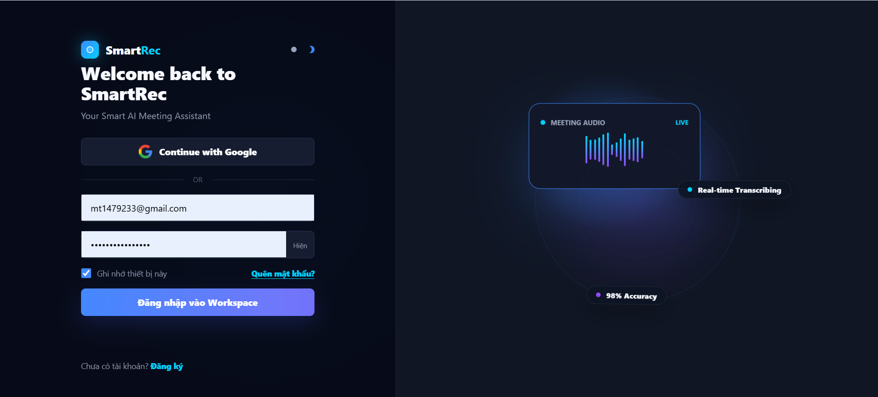
Figure 1: Login Page Interface

Table 1: Login Page Interface Specification
Display | SmartRec Login Page
Description | Secure entry point for registered users of the SmartRec platform.
Show access | Accessed via primary domain or when a user is unauthenticated.
Displayed Content
Item | Type | Data | Description
App Branding & Welcome Text | Text / Icon | Logo "SmartRec", Text: "Welcome back to SmartRec", Subtitle: "Your Smart AI Meeting Assistant" | Displays the application brand and introduces the platform's core value
Theme Toggle | Toggle Switch | Sun and Moon icons | Allows users to switch the interface between light and dark modes
Social Login Button | Button | Google "G" Icon, Text: "Continue with Google" | Quick and secure authentication via Google OAuth.
Email Field | Text Input | Value: "mt1479233@gmail.com" | Input field for the user's email address.
Password Field | Secure Input | Hidden text (dots), Toggle text: "Hiện". | Input field for the user's password, including a toggle to show/hide characters.
Remember Me | Checkbox | Label: "Ghi nhớ thiết bị này" (Checked). | Option to keep the user logged in on the current device for future sessions
Forgot Password | Link | Text: "Quên mật khẩu?" (Blue text). | Navigation link to the password recovery page
Primary Login Button | Primary Button | Text: "Đăng nhập vào Workspace", BG: Blue/Purple gradient | Main action button to submit credentials and access the application
Sign Up Prompt | Text / Link | Text: "Chưa có tài khoản? Đăng ký". | Navigation link to the registration page for new users.
Decorative AI Graphic | Illustration | Audio wave visual, Tags: "MEETING AUDIO LIVE", "Real-time Transcribing", "98% Accuracy". | Visual representation of SmartRec's core AI capabilities displayed on the right panel.
Action Name | Describe | Success | Unsuccessful
Click "Continue with Google" | User clicks the Google OAuth button. | Join via PIN Authenticates the user via Google and redirects to the Workspace. | OAuth connection fails or is canceled by the user
Card Action Toggle Password Visibility | User clicks "Hiện" inside the password field. | Password characters become visible (text changes to "Ân" or similar) | None.
Submit "Đăng nhập vào Workspace" | User clicks the primary login button. | Credentials are validated, and the user is redirected to the Dashboard/Workspace | Authentication fails; an error message (e.g., "Invalid credentials") is displayed.
Click "Quên mật khẩu?" | User clicks the forgot password link. | Navigates to the password reset screen | Page load error.
Click "Đăng ký" | User clicks the sign-up link. | Navigates to the user registration screen | Page load error.

2.2. Sign Up Interface
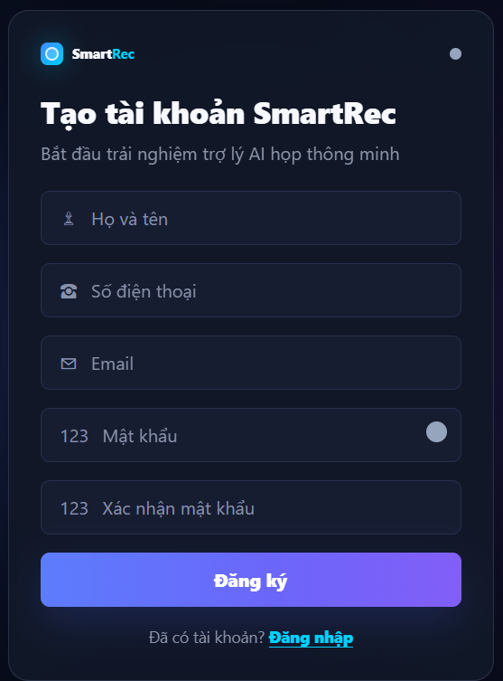
Figure 2: Sign Up Interface

Table 2: Sign Up Interface Specification
Display | User Register New Account
Description | New account creation interface for users to register on the SmartRec platform.
Show access | Accessed by clicking the sign-up link from the login page or via a direct registration URL.
Displayed Content
Item | Type | Data | Description
App Branding & Welcome Text | Text/Icon | Logo "SmartRec", Title: "Tạo tài khoản SmartRec", Subtitle: "Bắt đầu trải nghiệm trợ lý AI họp thông minh". | Displays the application brand and introduces the purpose of the page
Theme Toggle | Toggle Switch | Circle icon at the top right. | Allows users to switch the interface theme (e.g., light/dark mode).
Full Name Field | Text Input | Person icon, Placeholder: "Họ và tên". | Input field for the user to enter their complete name.
Phone Number Field | Text Input | Telephone icon, Placeholder: "Số điện thoại". | Input field for the user's contact phone number
Email Field | Text Input | Envelope icon, Placeholder: "Email" | Input field for the user's primary email address, which will serve as the account identifier.
Password Field | Secure Input | "123" icon, Placeholder: "Mật khẩu", Circle toggle icon on the right. | Input field for credential setup, including a toggle to show or hide the password characters
Confirm Password Field | Secure Input | "123" icon, Placeholder: "Xác nhận mật khẩu" | Verification field to ensure the user typed their intended password correctly.
Sign Up Button | Primary Button | Text: "Đăng ký", BG: Blue/Purple gradient | Main call-to-action button to submit the registration form and create the account
Login Prompt | Text / Link | Text: "Đã có tài khoản?", Link: "Đăng nhập" (Highlighted in blue) | Navigation link to redirect existing users back to the authentication screen
Action Name | Describe | Success | Unsuccessful
Input Data | User types information into the Name, Phone, Email, and Password fields. | The fields capture the input data, and input borders may highlight to indicate focus. | Real-time validation fails (e.g., invalid email format, passwords do not match)
Toggle Password Visibility | User clicks the circle icon inside the password field | Password characters switch between visible text and hidden dots | None
Submit "Đăng ký" | User clicks the primary sign-up button. | Form data is validated, the new user profile is created in the database, and the user is redirected | Registration fails due to backend errors (e.g., email already exists, network timeout).
Click "Đăng nhập" | User clicks the login link at the bottom | Navigates the user back to the Login interface | Page load error.

2.3. Forgot Password Step1 Interface

2.3.1. Forgot Password Step1 Interface

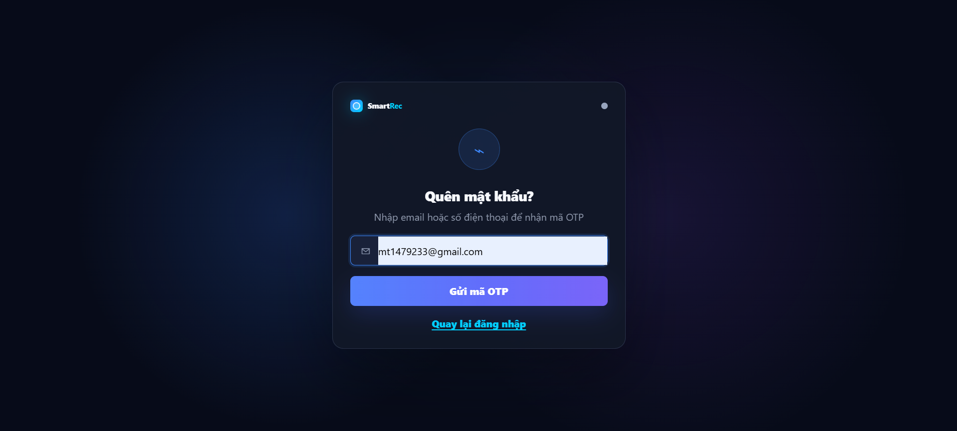

Table: Forgot Password Interface Specification

Display | Forgot Password Portal
Description | Interface for users to initiate the password recovery process by requesting an OTP code.
Show access | Accessed by clicking the "Quên mật khẩu?" (Forgot password) link from the Login page.

Element | Type | Details | Description
App Branding | Text / Icon | Logo "SmartRec" at the top left. | Displays the application brand.
Theme Toggle | Toggle Switch | Circle icon at the top right. | Allows users to switch the interface theme (light/dark mode).
Header Graphic | Icon | Circular icon with a lightning bolt/action symbol in the center. | Decorative visual element emphasizing the recovery action.
Page Title & Subtitle | Heading / Text | Title: "Quên mật khẩu?", Subtitle: "Nhập email hoặc số điện thoại để nhận mã OTP". | Instructs the user on how to recover their account.
Account Identifier Field | Text Input | Envelope icon, Value shown: "mt1479233@gmail.com". | Input field for the user to provide their registered email address or phone number.
Submit Button | Primary Button | Text: "Gửi mã OTP", BG: Blue/Purple gradient. | Main call-to-action button to trigger the OTP generation and sending process.
Back to Login Link | Link | Text: "Quay lại đăng nhập" (Highlighted in cyan/blue). | Navigation link to cancel the recovery process and return to the login screen.

Action Name | Describe | Success | Unsuccessful
Input Account Identifier | User types their email or phone number into the input field. | The field captures the input data, and the border highlights (blue) to indicate focus. | Real-time validation fails (e.g., invalid email/phone format).
Click "Gửi mã OTP" | User clicks the primary submit button. | System verifies the account exists, generates an OTP, sends it to the user, and navigates to the OTP Verification screen. | Account not found in the database, or backend network error occurs.
Click "Quay lại đăng nhập" | User clicks the return link at the bottom. | Navigates the user back to the Login interface. | Page load error.

2.3.2. Forgot Password Step2 Interface

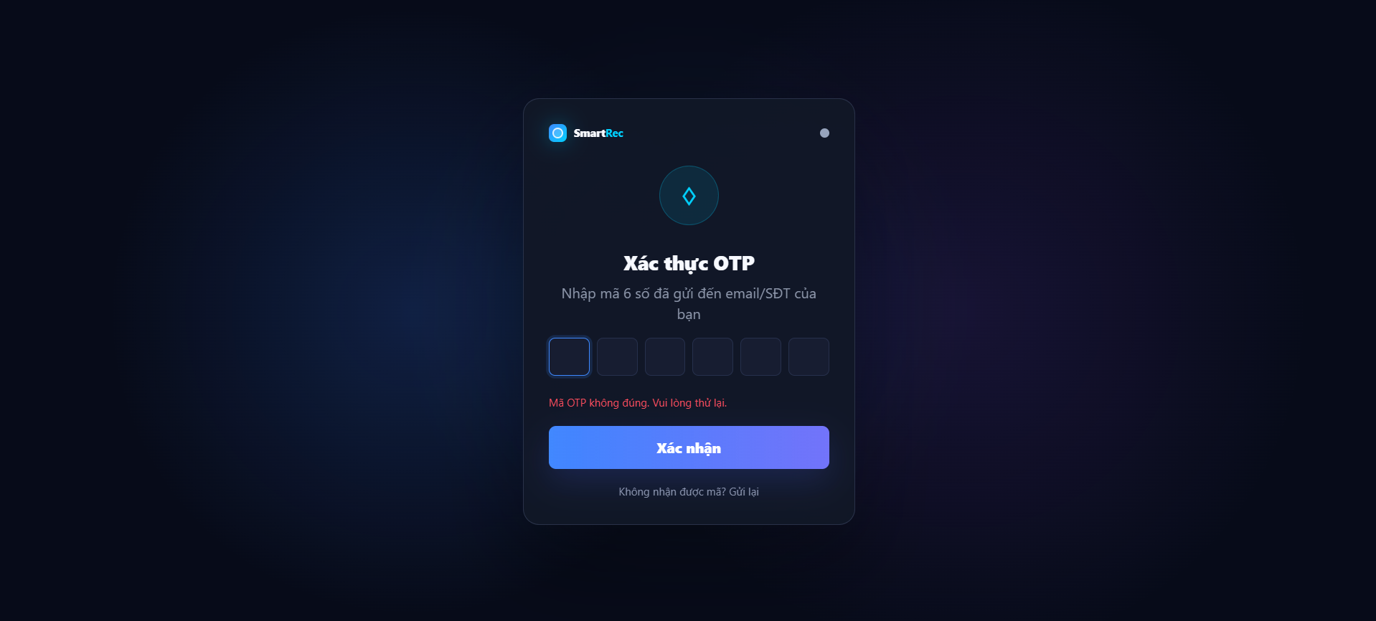

Table: Forgot Password Step2 Interface Specification

Field | Details
Display | OTP Verification Portal
Description | Interface for users to verify their identity by entering a 6-digit One-Time Password (OTP) sent to their email or phone.
Show access | Displayed immediately after the user submits a request on the "Forgot Password" or registration screens.

Element | Type | Details | Description
App Branding | Text / Icon | Logo "SmartRec" at the top left. | Displays the application brand.
Theme Toggle | Toggle Switch | Circle icon at the top right. | Allows users to switch the interface theme (light/dark mode).
Header Graphic | Icon | Circular icon with a cyan diamond/shield symbol in the center. | Decorative visual element emphasizing security and verification.
Page Title & Subtitle | Heading / Text | Title: "Xác thực OTP", Subtitle: "Nhập mã 6 số đã gửi đến email/SĐT của bạn". | Instructs the user on the required action and specifies the 6-digit format.
OTP Input Fields | Numeric Input | 6 individual square input boxes. The active box is highlighted with a blue border. | Input area specifically designed for the 6-digit OTP code.
Error Message | Text Info | Red text: "Mã OTP không đúng. Vui lòng thử lại.". | Validation feedback indicating that the entered OTP is incorrect.
Confirm Button | Primary Button | Text: "Xác nhận", BG: Blue/Purple gradient. | Main call-to-action button to submit the entered OTP for backend validation.
Resend Link | Text / Link | Text: "Không nhận được mã? Gửi lại". | Actionable text to request a new OTP if the user did not receive the code or if it expired

Action Name | Describe | Success | Unsuccessful
Input OTP Code | User types digits into the 6 input boxes. | Focus automatically advances to the next box as each digit is typed. | User attempts to enter non-numeric characters (prevented by UI).
Submit "Xác nhận" | User clicks the primary confirm button. | OTP is validated successfully, and the user is redirected to the Reset Password screen. | OTP is invalid or expired; the red error message "Mã OTP không đúng. Vui lòng thử lại." is displayed.
Click "Gửi lại" | User clicks the resend link at the bottom of the form. | System generates a new OTP, sends it to the user's contact method, and resets any cooldown timers. | Maximum resend limit reached or network failure occurs.

2.3.3. Forgot Password Step 3 Interface

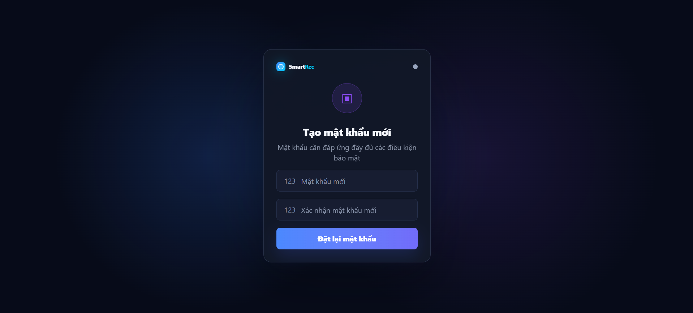

Table: Forgot Password Step 3 Interface Specification

Field | Details
Display | Create New Password Portal
Description | The interface allows users to set a new password after successful OTP authentication.
Show access | Displays automatically immediately after the user enters the correct OTP during the OTP verification step.

Element | Type | Details | Description
App Branding | Text / Icon | "SmartRec" logo in the top-left corner. | Displays the application branding.
Theme Toggle | Toggle Switch | Small circular icon in the top-right corner. | Allows users to toggle light/dark mode.
Header Graphic | Icon | Purple circular icon with an inner small square. | Decorative graphic highlighting the security setup action.
Page Title & Subtitle | Heading / Text | Title: "Create New Password", Subtitle: "Password must meet all security requirements". | Instructs the user to create a new password meeting security rules.
New Password Field | Secure Input | "123" icon, Placeholder: "New Password". | Input field for users to enter their new password.
Confirm Password Field | Secure Input | "123" icon, Placeholder: "Confirm New Password". | Verification input field to ensure the user entered the intended password correctly.
Submit Button | Primary Button | Text: "Reset Password", BG: Blue/Purple gradient. | Primary call-to-action button to submit the new password to the system.

Action Name | Describe | Success | Unsuccessful
Input New Password | User enters characters into the "New Password" field. | Data is captured; the input box border may change color to indicate active input. | Password does not meet basic security requirements (if real-time validation is enabled).
Input Confirm Password | User re-enters the character string into the "Confirm New Password" field. | Data is captured. | Entered characters do not match the password field above.
Submit "Reset Password" | User clicks the "Reset Password" button. | Password is successfully updated in the database; user is redirected to the Login page with a success message. | Update fails due to network error, server error, or expired session.

2.3. Home Page Interface

2.3.1. Home Page Interface

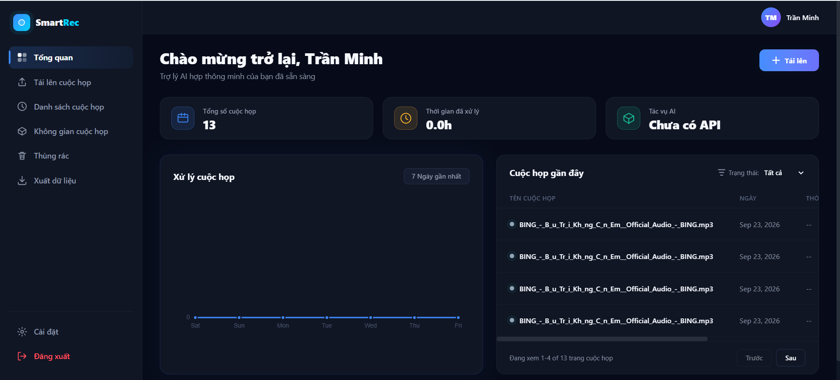
Figure 3: DashBoard Interface

Table 3: DashBoard Interface Specification
Display | User Dashboard Portal
Description | Main landing page for authenticated users, providing a high-level overview of meeting statistics and recent activities
Show access | Displayed automatically after a successful login or by clicking "Tổng quan" in the main navigation sidebar.
Displayed Content
Item | Type | Data | Description
Main Navigation Sidebar | Sidebar Menu | Links: Tổng quan (Active), Tải lên cuộc họp, Danh sách cuộc họp, Không gian cuộc họp, Thùng rác, Xuất dữ liệu. | Primary navigation for accessing different modules of the application.
Bottom Sidebar Actions | Menu Items | "Cài đặt" (Settings icon), "Đăng xuất" (Logout icon, Red text). | Access to system settings and account logout.
User Profile / Header | Header Component | Title: "Chào mừng trở lại, Trần Minh", Subtitle: "Trợ lý AI họp thông minh của bạn đã sẵn sàng". | Personalized greeting for the user.
Welcome Message | Heading & Text | Visibility toggle  Strength meter (4 levels) | Credential setup
Upload Button | Primary Button | Text: "+ Tải lên", BG: Blue | Quick action button to initiate a new meeting upload.
Total Meetings Card | Metric Card | Icon: Calendar, Label: "Tổng số cuộc họp", Value: "13". | Displays the total number of meetings processed or uploaded by the user
Processing Time Card | Metric Card | Icon: Clock, Label: "Thời gian đã xử lý", Value: "0.0h". | Displays the total cumulative duration of audio/video processed
AI Tasks Card | Metric Card | Icon: Box/Cube, Label: "Tác vụ AI", Value: "Chưa có API" | Displays the status or count of AI-related tasks
Processing Chart | Line Chart | Title: "Xử lý cuộc họp", Filter: "7 Ngày gần nhất", X-axis: Days of week (Sat-Fri). | Visual representation of meeting processing activity over a selected time period.
Recent Meetings List | Data List | Title: "Cuộc họp gần đây", Filter: "Trạng thái: Tất cả" | Shows a truncated list of recently uploaded or processed meetings.
Meeting List Items | List Rows | Columns: TÊN CUỘC HỌP, NGÀY, THỜI GIAN (truncated). | Individual records showing meeting file names (e.g., .mp3 files) and creation dates.
Pagination Controls | Navigation | Text: "Đang xem 1-4 of 13 trang cuộc họp", Buttons: "Trước", "Sau". | Controls to navigate through the list of recent meetings.
Action Name | Describe | Success | Unsuccessful
Click "+ Tải lên" | User clicks the primary upload button. | Navigates to the file upload interface/module | None.
Change Chart Filter | User clicks the "7 Ngày gần nhất" button | Opens a dropdown or updates the chart to show data for a different time range. | Data fails to load.
Change Meeting Status Filter | User clicks the "Trạng thái: Tất cả" dropdown | Updates the recent meetings list to show only meetings matching the selected status | None.
Click "Trước" / "Sau" | User clicks the pagination buttons. | Loads the previous/next set of meeting records in the list. | End of list reached (buttons may be disabled).
Click "Đăng xuất" | User clicks the logout link in the sidebar. | Terminates the user session and redirects to the login screen. | None.

2.4. Profile Page Interface
2.4.1. Profile Page Interface Specification

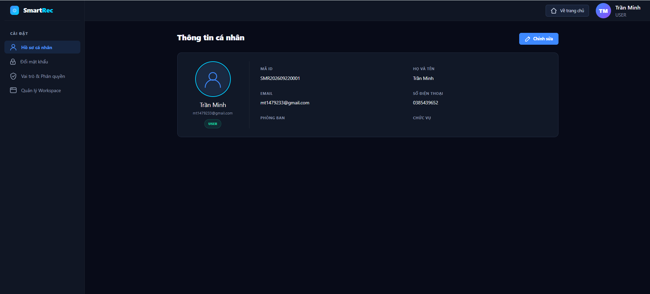
Figure 4: Profile Page Interface

Table 4: Profile Page Interface for student Specification

Field | Details
Display | User Profile Portal
Description | Account settings management interface, allowing users to view detailed personal information and access other system settings.
Show access | Accessed via the "Settings" option on the main navigation bar, or by clicking the user icon in the top-right corner of the screen.

Element | Type | Data / Details | Description
Top Navigation Bar | Header | Logo "SmartRec", "Back to Home" button, Summary user info (Avatar "TM", Name "Trần Minh", Role "USER"). | Top navigation bar displaying brand identity and a shortcut back to the homepage.
Settings Sidebar | Sidebar Menu | Title: "SETTINGS". Items: "Personal Profile" (Currently selected - highlighted), "Change Password", "Roles & Permissions", "Workspace Management". | Left sidebar menu used to navigate between account and system setting modules.
Page Title | Heading | Title: "Personal Information". | Main title of the currently displayed content area.
Edit Button | Secondary Button | Text: "Edit", Icon: Pencil, BG: Blue. | Action button to switch to update/edit mode for personal information.
User Avatar Card | Display Box | User icon, Name: "Trần Minh", Email: "mt1479233@gmail.com", Status/Role badge: "USER" (Blue border). | Display card showing avatar and summary identification information of the user.
Information Grid | Data Grid | Fields: ID CODE, FULL NAME, EMAIL, PHONE NUMBER, DEPARTMENT, POSITION. | Data grid displaying detailed profile fields of the user.
Information Values | Text | ID: "SMR202609220001", Name: "Trần Minh", Email: "mt1479233@gmail.com", Phone: "0385439652", Department/Position: Left blank. | Actual values corresponding to the information fields in the Information Grid.
Action Name | Describe | Success | Unsuccessful
Click "Edit" | User clicks the edit button at the top-right corner of the information area. | Interface switches to Form mode, allowing data entry/editing (e.g., updating phone number, department). | Page loading error or user lacks edit permissions.
Click Sidebar Item | User clicks on other items in the left sidebar menu (e.g., "Change Password"). | Main content area updates to display the interface corresponding to the selected item. | Navigation error.
Click "Back to Home" | User clicks the home icon/button on the top navigation bar. | System redirects the user back to the application's main Dashboard. | Redirection failed.

2.5. Update Profile

2.5.1. Update Profile
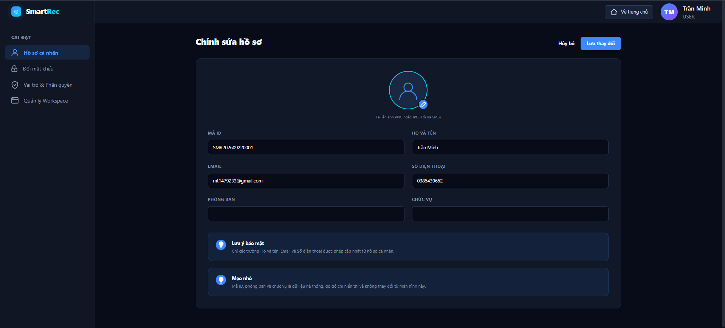
Figure 5: Update profile
Table 5: Update profile Specification
Field | Details
Display | Edit Profile Portal
Description | Input form interface allowing users to update their avatar and change basic personal information.
Show access | Accessed by clicking the "Edit" button from the User Profile screen.
Element | Type | Data / Details | Description
Page Title | Heading | Title: "Edit Profile" | Main title confirming that the interface is currently in edit mode.
Cancel Button | Text Button | Text: "Cancel" | Secondary button to discard edits and return to the previous view screen.
Save Button | Primary Button | Text: "Save Changes", BG: Blue | Primary call-to-action button to save the updated information to the database.
Avatar Upload Area | Image / Button | User avatar with a blue pencil icon. Guide text: "Upload PNG or JPG image (Max 5MB)". | Interactive area allowing users to upload a new avatar with format and file size limits.
Editable Fields | Text Input | Fields: FULL NAME (Trần Minh), EMAIL (mt1479233@gmail.com), PHONE NUMBER (0385439652). | Input fields allowing users to edit personal information.
Read-only Fields | Disabled Input | Fields: ID CODE (SMR202609220001), DEPARTMENT, POSITION. | System data fields displayed as read-only; users cannot modify them on this screen.
Security Note Banner | Info Box | Icon: Blue light bulb. Text: "Security note: Only Full Name, Email, and Phone Number are allowed to be updated from personal profile.". | Info banner explaining user permissions for editing sensitive/profile information.
System Tip Banner | Info Box | Icon: Blue light bulb. Text: "Tip: ID Code, department, and position are system data, thus displayed as read-only and cannot be changed from this screen.". | Info banner explaining the reason why certain data fields are locked (read-only).
Action Name | Describe | Success | Unsuccessful
Click Avatar Edit Icon | User clicks the pencil icon on the avatar area. | Opens the operating system's File Picker dialog to select a new image. | Selected file is in an invalid format (not PNG/JPG) or exceeds 5MB; system displays an error message.
Input Data | User clears or enters new text into Full Name, Email, and Phone Number fields. | Form captures and accepts the new text data. | Invalid format entered (e.g., letters in the Phone Number field, invalid email structure).
Click "Cancel" | User clicks the "Cancel" button in the top-right corner. | Discards all unsaved changes and redirects back to the view-only Personal Profile screen. | None.
Click "Save Changes" | User clicks the blue "Save Changes" button. | System validates data successfully, updates the database, displays a success notification, and redirects back to the profile view screen. | Network connection failure, or entered data violates backend validation rules.

2.5. Change Password Page
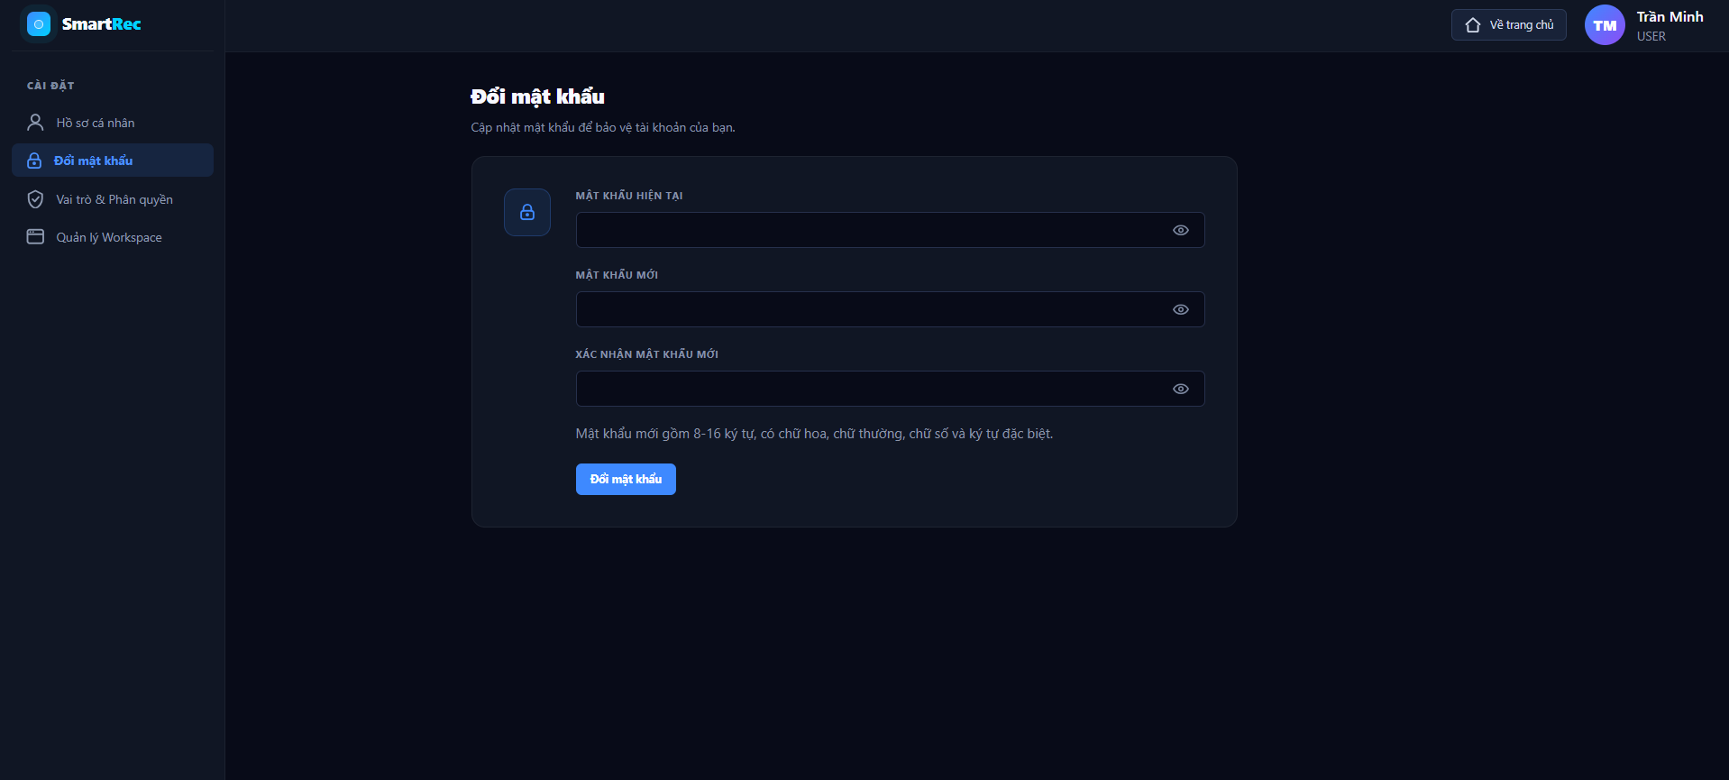
Figure 6: Change Password
Table 6: Change Password Specification

Display | Change Password Portal (Đổi mật khẩu)
Description | Giao diện cho phép người dùng đang đăng nhập thay đổi mật khẩu tài khoản để tăng cường bảo mật.
Show access | Truy cập bằng cách chọn mục "Đổi mật khẩu" trên thanh menu Cài đặt (Settings Sidebar) bên trái.
Element | Type | Data / Details | Description
Sidebar | Sidebar Menu | Mục đang chọn (Active): "Đổi mật khẩu" (Highlight viền xanh). | Menu điều hướng nội bộ của phân hệ Cài đặt, xác nhận người dùng đang ở đúng trang Đổi mật khẩu.
Page Title & Subtitle | Heading / Text | Tiêu đề: "Đổi mật khẩu", Phụ đề: "Cập nhật mật khẩu để bảo vệ tài khoản của bạn.". | Cho biết mục đích của giao diện hiện tại.
Security Graphic | Icon | Biểu tượng hình ổ khóa bên trong ô vuông bo góc màu xanh đen. | Đồ họa trực quan minh họa cho tính năng bảo mật.
Current Password Field | Secure Input | Label: "MẬT KHẨU HIỆN TẠI", Icon: Hình con mắt ở góc phải. | Trường nhập liệu yêu cầu người dùng cung cấp mật khẩu cũ để xác thực quyền sở hữu.
New Password Field | Secure Input | Label: "MẬT KHẨU MỚI", Icon: Hình con mắt ở góc phải. | Trường nhập liệu để thiết lập mật khẩu mới.
Confirm Password Field | Secure Input | Label: "XÁC NHẬN MẬT KHẨU MỚI", Icon: Hình con mắt ở góc phải. | Trường nhập liệu xác minh lại để đảm bảo người dùng gõ chính xác mật khẩu mới.
Password Policy Note | Text Info | Text: "Mật khẩu mới gồm 8-16 ký tự, có chữ hoa, chữ thường, chữ số và ký tự đặc biệt.". | Hướng dẫn và ràng buộc về độ phức tạp của mật khẩu để đảm bảo an toàn.
Submit Button | Primary Button | Text: "Đổi mật khẩu", BG: Xanh dương. | Nút thao tác chính (Call-to-action) để gửi yêu cầu đổi mật khẩu lên hệ thống.

2.6. Roles and Permissions

2.6.1. Roles and Permissions Interface
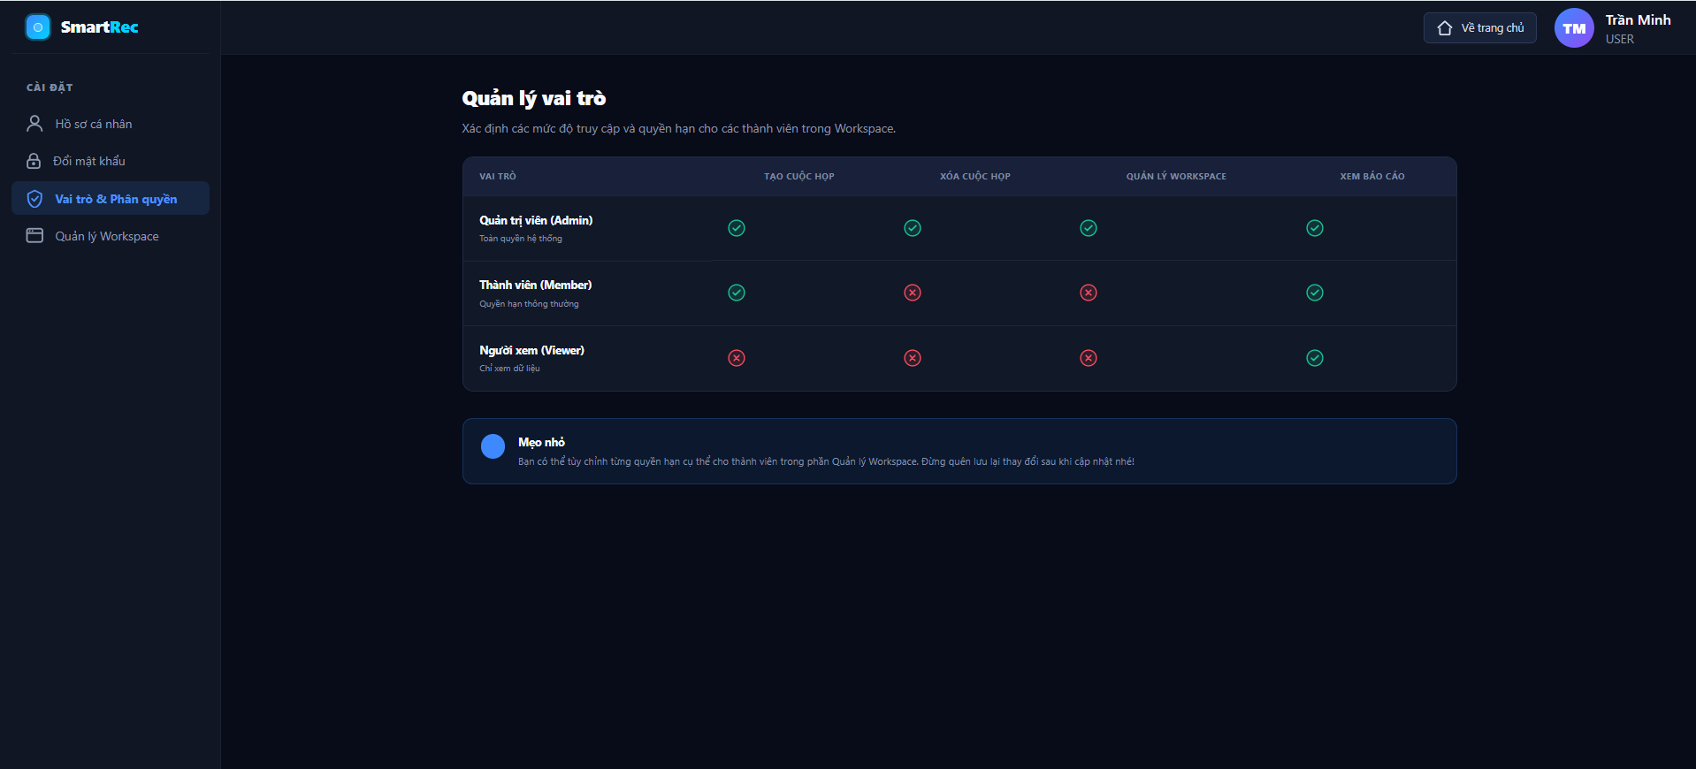
Figure 7: Roles and Permissions
Table 7: Roles and Permissions Specification
Field | Details
Display | Roles & Permissions Portal
Description | Interface displaying the permission matrix, helping users understand access levels and operational limits for each role within the SmartRec system.
Show access | Accessed by selecting the "Roles & Permissions" option (shield icon with a checkmark) on the left-hand Settings menu.
Element | Type | Data / Details | Description
Settings Sidebar | Sidebar Menu | Active item: "Roles & Permissions" (Blue background highlight, blue border). | Internal navigation menu confirming that the user is on the permissions interface.
Page Title & Subtitle | Heading / Text | Title: "Role Management", Subtitle: "Define access levels and permissions for members in the Workspace.". | Describes the primary purpose of the screen: managing and explaining role permissions.
Permissions Matrix | Data Table | Columns: ROLE, CREATE MEETING, DELETE MEETING, WORKSPACE MANAGEMENT, VIEW REPORTS. | Visual matrix table comparing roles against system capabilities and permissions.
Admin Role Row | Table Row | Name: "Administrator (Admin)" - "Full system permissions". Green checkmarks in all 4 feature columns. | Displays the unrestricted permissions granted to the Admin role.
Member Role Row | Table Row | Name: "Member" - "Standard permissions". Green checkmarks for "Create Meeting" and "View Reports"; red X marks for "Delete Meeting" and "Workspace Management". | Displays standard permissions: allows adding data, but restricts deletion and workspace management.
Viewer Role Row | Table Row | Name: "Viewer" - "Read-only". Green checkmark for "View Reports"; red X marks for the other 3 features. | Displays the lowest permission tier: read-only access to view data.
Permission Indicators | Icons | Circular icon with a green checkmark (Allowed), Circular icon with a red X (Not allowed). | Visual indicators helping users easily distinguish allowed vs. disallowed permissions in the matrix.
System Tip Banner | Info Box | Icon: Blue circle. Text: "Tip: You can customize specific permissions for members in the Workspace Management section...". | Informational banner guiding users to the Workspace Management tab to modify actual member permissions.

2.7. Upload Meeting Interface

2.7.1. Upload Meeting Interface Specification
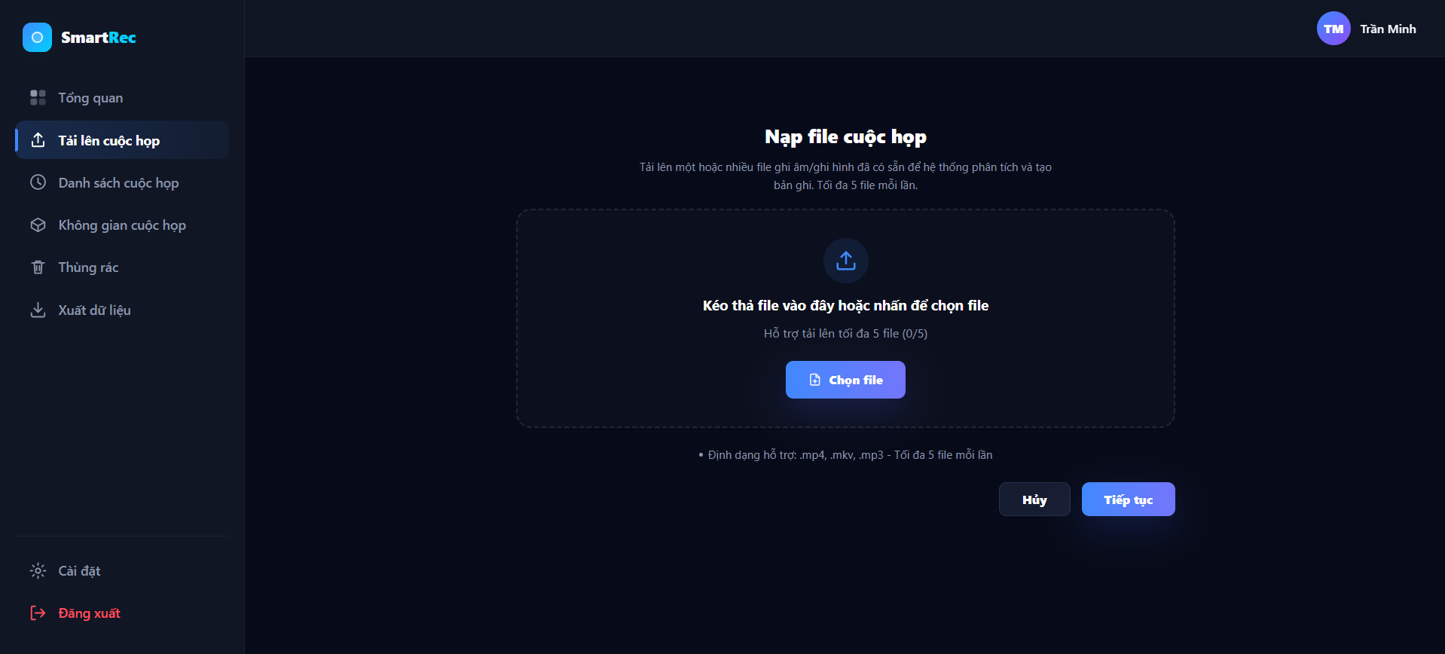
Figure 8: Upload Meeting Interface
Table 8: Upload Meeting Interface Specification
Field | Details
Display | Upload Meeting Portal
Description | Interface allowing users to upload meeting audio or video files for the AI system to analyze and extract data.
Show access | Accessed by selecting the "Upload Meeting" option on the main navigation menu on the left.
Element | Type | Data / Details | Description
Main Navigation Sidebar | Sidebar Menu | Active item: "Upload Meeting" (Highlighted with background color and blue border line). | Navigation menu confirming the user's current location within the system.
Page Title & Subtitle | Heading / Text | Title: "Upload Meeting File", Subtitle: "Upload one or more existing audio/video files for system analysis and transcript generation. Maximum 5 files per upload.". | Describes the purpose of the page and specifies the maximum file upload limit per batch.
Upload Dropzone | Drag & Drop Area | Dashed border frame. Icon: Upload arrow. Main text: "Drag and drop files here or click to select files". | Primary interactive area allowing users to drag and drop files from their computer into the browser.
File Counter | Text Info | Text: "Supports uploading up to 5 files (0/5)". | Counter displaying the current number of selected files against the maximum allowed limit.
Select File Button | Button | Text: "Choose File", Icon: Document icon, BG: Blue. | Secondary button inside the dropzone to trigger the operating system's file picker dialog.
Supported Formats Note | Text Info | Text: "* Supported formats: .mp4, .mkv, .mp3 - Maximum 5 files per upload". | Informational note reminding users of valid media file formats accepted by the system.
Cancel Button | Secondary Button | Text: "Cancel", BG: Dark (no prominent border). | Action button to cancel the file preparation process and reset the interface.
Continue Button | Primary Button | Text: "Continue", BG: Blue/Purple gradient. | Primary call-to-action button to confirm selected files and proceed to the next step.
Action Name | Describe | Success | Unsuccessful
Drag & Drop File | User drags media files from their computer and drops them into the dashed border area (Dropzone). | The UI updates to display the list of dropped files; the counter (0/5) increases accordingly. | File is rejected if format is invalid (not .mp4, .mkv, .mp3) or total count exceeds 5 files.
Click "Choose File" | User clicks the blue "Choose File" button. | Opens the operating system's File Explorer/Finder window to browse and select files. | None.
Click "Cancel" | User clicks the "Cancel" button at the bottom. | Clears all selected pending files from the temporary list; restores the interface to its initial state. | None.
Click "Continue" | User clicks the "Continue" button after adding files to the Dropzone. | System records valid files and redirects the user to the next screen (e.g., AI configuration settings screen). | The "Continue" button may be disabled if no files have been selected or if there are invalid files.

2.8. List Meeting Interface

2.8.1. List Meeting Interface Specification
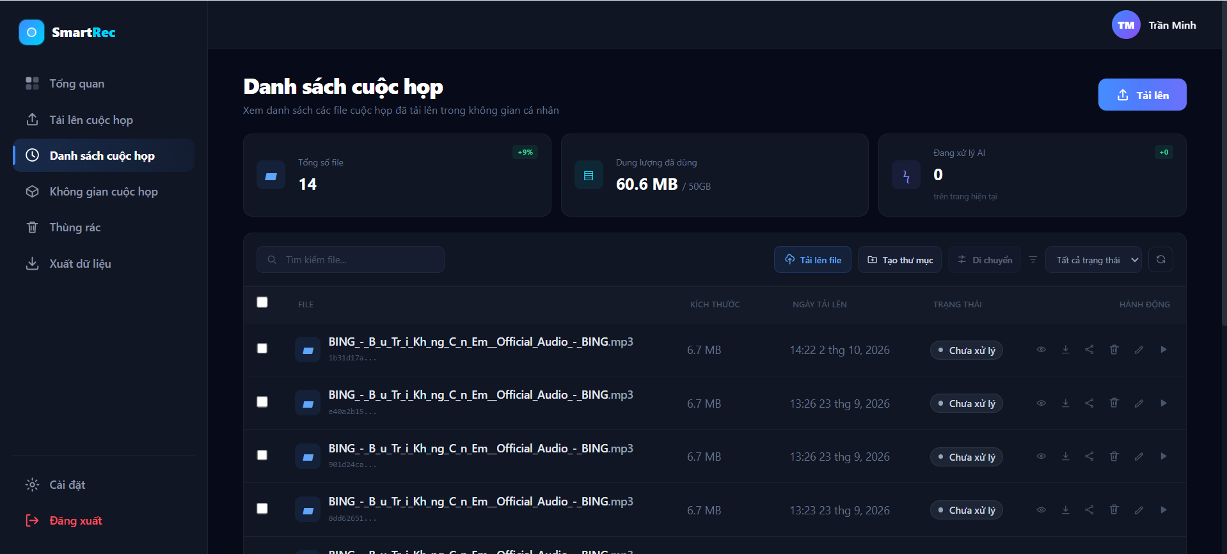
Figure 9: List Meeting Overview
Table 9: List Meeting overview Interface Specifications
Field | Details
Display | Meeting List Portal
Description | Interface for managing the list of meeting audio/video files uploaded to personal storage, including storage statistics and file management tools.
Show access | Accessed by selecting the "Meeting List" option (clock icon) on the main navigation menu on the left.
Element | Type | Data / Details | Description
Main Navigation Sidebar | Sidebar Menu | Active item: "Meeting List". | Navigation menu confirming the user's current location within the system.
Page Title & Subtitle | Heading / Text | Title: "Meeting List", Subtitle: "View the list of uploaded meeting files in personal space". | Describes the main function of the screen.
Top Upload Button | Primary Button | Text: "Upload", Icon: Upward arrow, BG: Light blue. | Quick access button in the top-right corner to initiate the file upload process.
Total Files Card | Metric Card | Label: "Total Files", Value: "14", Badge: "+9%" (Green). | Metric card displaying the total number of files currently in the user's system.
Storage Card | Metric Card | Label: "Used Storage", Value: "60.6 MB / 50GB". | Metric card monitoring storage quota, displaying used storage over total quota.
Processing Card | Metric Card | Label: "AI Processing", Value: "0", Subtext: "on current page". | Metric card displaying the number of files currently in the AI processing queue.
Search Bar | Text Input | Placeholder: "Search files...", Icon: Magnifying glass. | Search bar allowing users to filter files by name.
Toolbar Actions | Button Group | Buttons: "Upload File", "Create Folder", "Move". | Group of tools supporting data organization and workspace management.
Status Filter | Dropdown | Default text: "All Statuses". | Filter helping display files by processing status (e.g., Processed, Unprocessed).
File Data Table | Data Table | Columns: (Checkbox), FILE, SIZE, UPLOAD DATE, STATUS, ACTION. | Main grid table displaying the detailed list of uploaded files.
Status Badge | Tag | Text: "Unprocessed" with a gray dot. | Visual badge indicating that the file has not yet been processed by the AI system.
Row Action Icons | Icon Buttons | Icons: Eye (View), Down arrow (Download), Share button, Trash (Delete), Pencil (Edit), Play button (Run AI). | Quick action shortcuts applied individually to each row (each file).

2.9. Meeting detail

Figure 10:
Table 10:
(Chưa gộp code/ cập nhật sau)

2.10.Meeting WorkSpace

2.10.1. Meeting WorkSpace Interface Specification
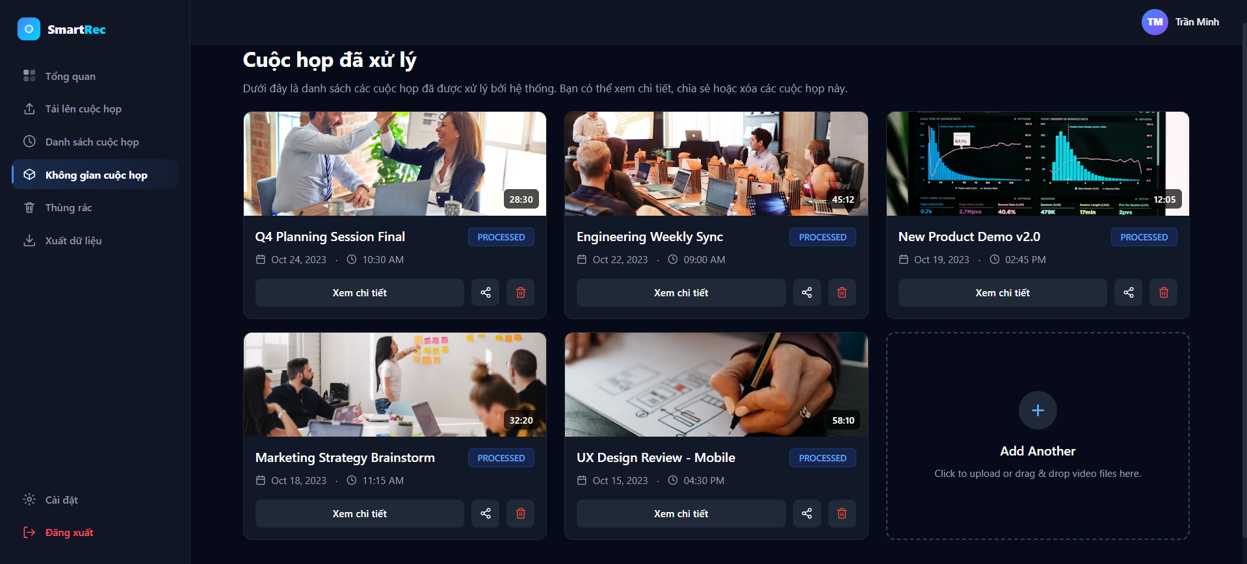

Figure 11: Meeting WorkSpace Interface
Table 11: Meeting WorkSpace Interface Specification
Field | Details
Display | Meeting Space Portal
Description | Grid-view interface displaying meetings fully processed by the AI system, allowing users to view details, share, or delete.
Show access | Accessed by selecting the "Meeting Space" option (hexagon icon) on the main navigation menu on the left.
Element | Type | Data / Details | Description
Main Navigation Sidebar | Sidebar Menu | Active item: "Meeting Space". | Navigation menu confirming the user's current location within the system.
Page Title & Subtitle | Heading / Text | Title: "Processed Meetings", Subtitle: "Below is the list of meetings processed by the system. You can view details, share, or delete these meetings.". | Describes the primary purpose and usage instructions for the screen.
Meeting Card | Card Component | Rounded corner card layout, dark background. | Container component representing a single meeting.
Video Thumbnail & Duration | Image / Badge | Preview image extracted from video, bottom-right corner shows duration badge (e.g., "28:30", "45:12"). | Representative visual image and total duration of the meeting video/audio.
Meeting Title | Heading | Bold text (e.g., "Q4 Planning Session Final", "Engineering Weekly Sync"). | Name/title of the uploaded meeting.
Status Badge | Tag | Text: "PROCESSED", BG: Dark blue, Light blue text. | Status badge indicating that AI has completed data extraction and analysis.
Meeting Metadata | Text Info | Calendar icon with date (e.g., Oct 24, 2023), Clock icon with time (e.g., 10:30 AM). | Information about when the meeting took place or when it was uploaded.
View Details Button | Button | Text: "View Details", stretched across the bottom part of the card. | Button to open the meeting detail screen (video player, transcript, summary).
Share Button | Icon Button | Icon: Share button. | Shortcut to share the meeting with other members.
Delete Button | Icon Button | Icon: Trash can, red border and icon. | Shortcut to delete the meeting.
Add Another Card | Drag & Drop Card | Dashed border frame, Icon: Plus (+), Text: "Add Another", Subtext: "Click to upload or drag & drop video files here.". | Utility area allowing users to drag and drop or click to quickly upload a new meeting file directly from this screen.
Action Name | Describe | Success | Unsuccessful
Click "View Details" | User clicks the "View Details" button on any meeting card. | The system navigates to the detailed Workspace interface of that meeting (Interactive Player, Task Matrix). | Data retrieval error from the Database.
Click Share Icon | User clicks the share icon button on the card. | Opens a Modal/Popup allowing the user to copy the link or enter the recipient's email to grant access permissions. | None.
Click Delete Icon | User clicks the red trash can icon button. | Displays a confirmation dialog. If confirmed, the meeting card is removed and moved to the "Trash" section. | User selects "Cancel" on the confirmation dialog.
Interact with "Add Another" | User clicks on the last dashed border card or drags and drops a file into it. | Activates the file browser dialog or initiates the upload progress similar to the "Upload Meeting" screen. | Uploaded file format is invalid or exceeds the allowed file size limit.

2.11. Trash RecycleBin Interface

2.11.1. Trash RecycleBin Interface Specification
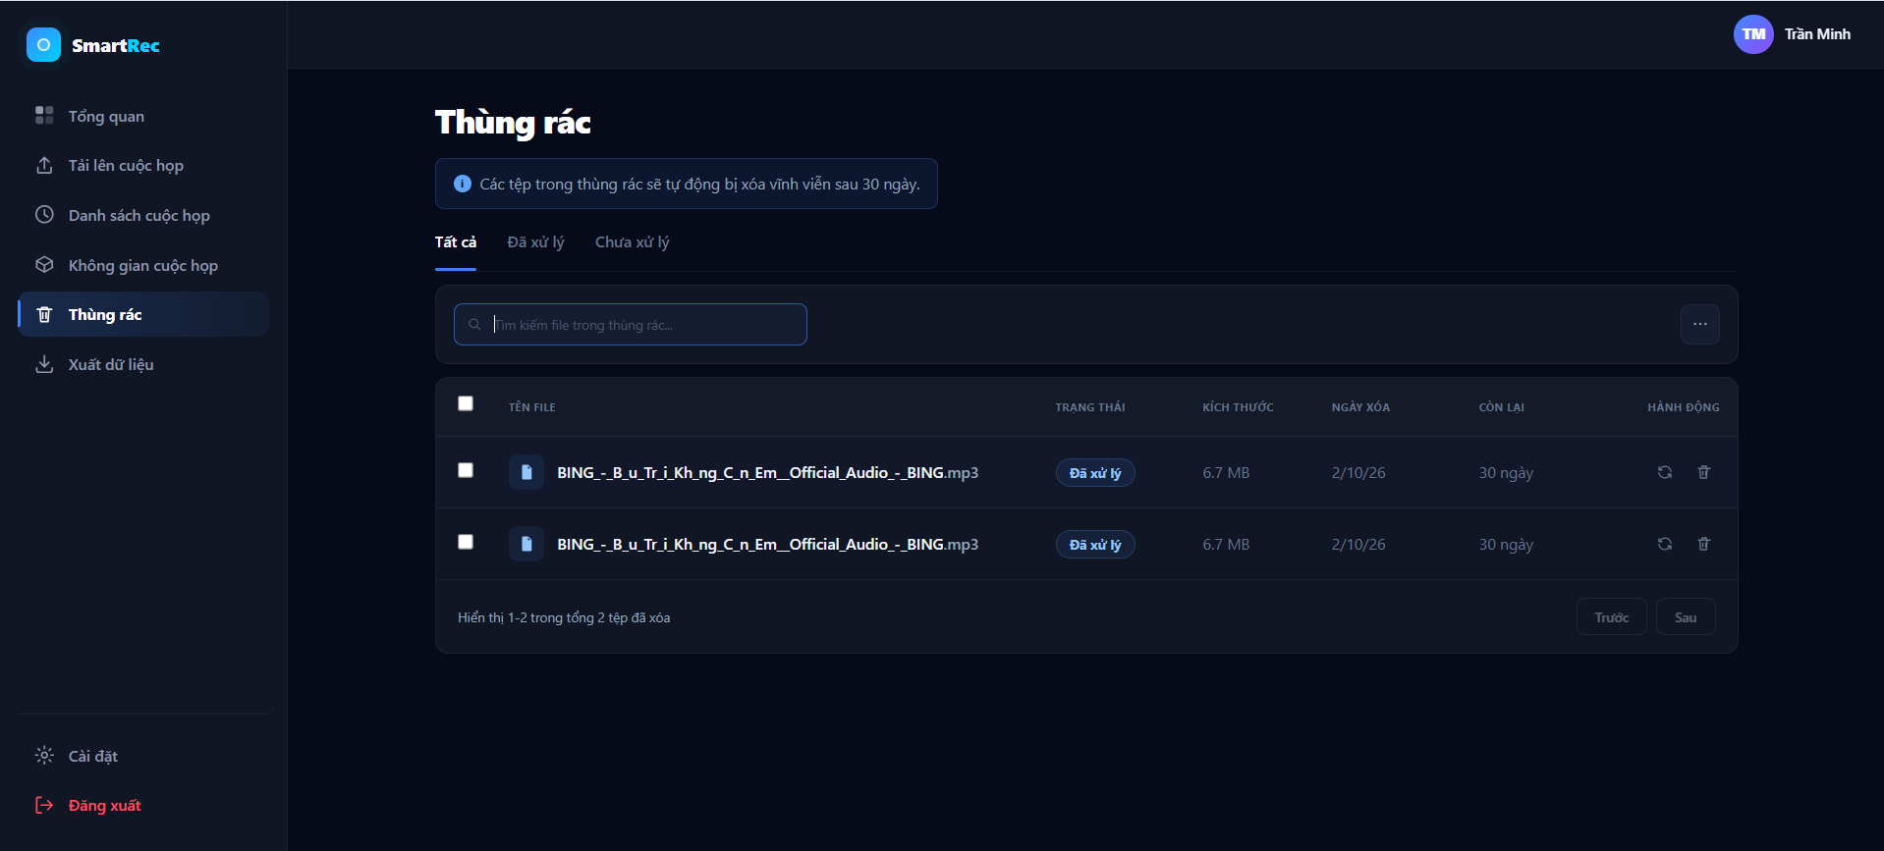
Figure 12: Trash RecycleBin Interface
Table 12: Trash RecycleBin Interface Specification
Field |  | Details
Display |  | Trash Portal
Description |  | Temporary storage interface for deleted files and meetings, allowing users to restore data or permanently delete them from the system.
Show access |  | Accessed by selecting the "Trash" option (trash can icon) on the main navigation menu on the left.
Element | Type | Data / Details | Description
Main Navigation Sidebar | Sidebar Menu | Active item: "Trash" (Blue background highlight, blue left border). | Navigation menu confirming the user's current location within the system.
Page Title | Heading | Title: "Trash". | Main title of the functional screen.
Retention Policy Banner | Info Box | Icon: Blue 'i'. Text: "Files in the trash will be automatically deleted permanently after 30 days.". | Information banner highlighting the system's data retention policy to alert users.
Category Tabs | Tab Navigation | Tabs: "All" (Active - blue underline), "Processed", "Unprocessed". | Quick filter tabs allowing classification of deleted files based on their prior AI processing status.
Search Bar | Text Input | Placeholder: "Search files in trash...", Icon: Magnifying glass. | Search bar to quickly locate specific deleted files.
More Options Button | Icon Button | Icon: Ellipsis ("..."). | Dropdown menu typically containing bulk action commands, such as "Empty Trash".
Trash Data Table | Data Table | Columns: (Checkbox), FILE NAME, STATUS, SIZE, DELETION DATE, REMAINING, ACTION. | Main grid table displaying the detailed list of files currently in the trash.
Status Badge | Tag | Text: "Processed", BG: Dark blue, light blue border and text. | Tag displaying the file's processing status prior to deletion.
Remaining Days | Text Info | E.g., "30 days". | Countdown timer showing the time remaining before the system permanently deletes the file.
Row Action Icons | Icon Buttons | Icons: Rotating arrow (Restore), Trash can (Delete permanently). | Direct action shortcuts applied to each individual file row in the table.
Pagination | Navigation | Text: "Showing 1-2 of 2 deleted files", Buttons: "Previous", "Next" (Disabled/dimmed). | Pagination navigation controls for when the list of deleted files is long.
Action Name | Describe | Success | Unsuccessful
Switch Tabs | User clicks on the "Processed" or "Unprocessed" tabs. | The list below automatically filters and displays only files corresponding to the selected status. | None.
Search Files | User types keywords into the Search box. | The file list updates to display deleted files whose names match the keyword. | No matching results found.
Click Restore Icon | User clicks the rotating arrow icon on a row. | The file disappears from Trash and is restored to its original location (Meeting List / Meeting Space); a success notification is displayed. | System error, restoration failed.
Click Permanent Delete Icon | User clicks the trash can icon on a row. | Displays a permanent deletion warning dialog. If confirmed, data is completely deleted from the database and storage cannot be recovered. | User selects "Cancel" on the warning dialog.

